 **NSTP JOURNAL NSTP REFLECTIVE JOURNAL**

**Name:** Hakuryu Acosta Kato **Year and Course:** BSCS-201

***Week No.: 1***

***Name of Activity: Barangay viewing***

***Date Conducted: march 12, 2025***

***Assigned Barangay: Barangay 75- Zone 10***

**D-1: BARANGAY VIEWING**

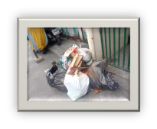

During the barangay viewing. The first thing that I reflected and seen during

this day was finding bunch of trash and litter in the streets therefore creating

this putrid smell in these streets thus making it hard to focus on other problems

in the barangay and making the whole class seeing that the main problem of

the barangay is it’s constant problem of the litter. When reflecting on this

situation, I noticed that their were few trash bins in the area causing people to

throw their trash in the ground. The lack of options to throw their garbage in

a trash bin can cause major impact to the environment and well-being of the

community

Another thing that I observe during the barangay viewing is how small and 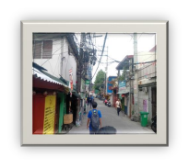

compacted the streets are, and how it is easy to cause havoc in the area that

can cause traffic jams that are led by road blockage, accidents, and many other factors.

But the main concern that I saw is how prone it is to creating a hazardous area

that could cause a lot of problems to the community and may harm the

children of the community. The thing that I observe about the community is

The social dynamics of the people. They were curious and enthusiastic about

What the whole class will do for the community and learn new techniques to

futher improve their barangay

Lastly, the most interesting thing that I observe is how the community 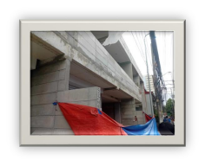

is getting some improvement in their commercial areas and how it’s

getting more of a modern urbanization progress. Which is very good

for the barangay, but I notice some problems with these sites. During the

Observation I saw how debris and materials are all over the place

outside the construction sites. It's not life-threatening, but a clean area

can really brighten the mood of the zones. But I can also give them

credit that they always warn the people of the community to have a

distance in the construction sites